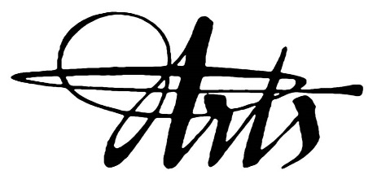
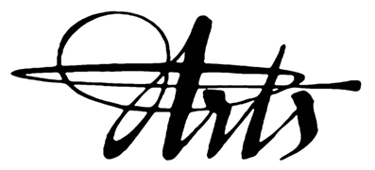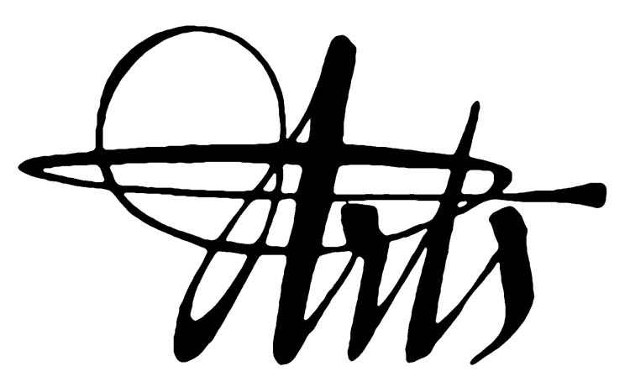
EXCELLENCE
THROUGH THE ARTS
APPLICATION

School:

Project Coordinator:

Artist selected:

1st Choice:

2nd Choice:

Note: 6 grants will be awarded to Visual Arts residencies and the other 6 to Performing Arts. If you are only interested in one specific artist, please leave the second choice blank; but be prepared to not receive a grant if we have reached our quota.

Projected dates of the residency:

Please provide a short description of what the 2 different residencies may look like:
ie: 1st Choice: Our 6 intermediate teachers will be working on drama games and character developments to strengthen our Language Arts program.

- Our school is aware of the $600 payable to SD23
- Plus any additional costs for materials discussed with the artist.
- Our school is committed to booking a ½ day TTOC to release teachers to co-plan with the artist.

MISSION STATEMENT
- to partner local artists with classroom teachers and students.
- to empower teachers through enhanced skills to incorporate the arts across the curriculum.

2023-2024 Application deadline:
- Thurs, September 28th, 2023 (Priority application for Westside zone schools)
- Thurs, October 19th, 2023 (General application for all SD23 schools)

Please email completed application form to Irene Wong at irene.wong@sd23.bc.ca

